**LAPORAN PRAKTIKUM**

Nama : Maftuchati

NIM : 18090015

Kelas : 5B

**PRAKTIKUM 3**

1. Source Code

* Matakuliah.php-> application/controller

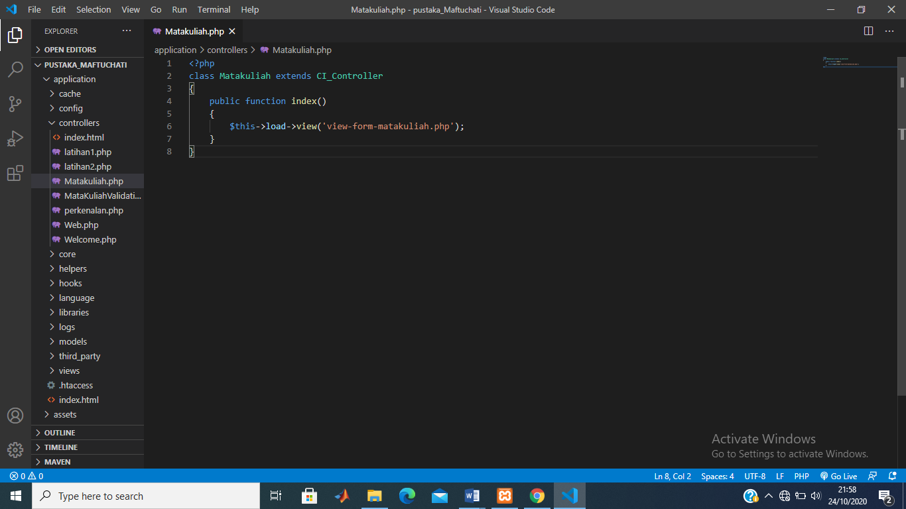

* View-form-matakuliah.php->application/view

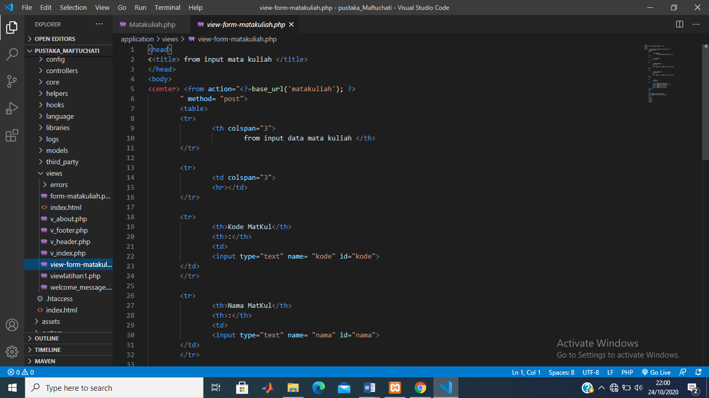

1. URL

<http://localhost/pustaka_Maftuchati/index.php/Matakuliah>

1. Capture Hasil

